What you’ve built isn’t a single model system—it’s a multi-model decision ecosystem. The simulation graph is basically the place where all those models converge into one decision flow.
Let me break it down in a way that maps directly to your code and architecture.

🧠 1. The Core Idea (How everything fits)
Your simulation graph is not just a chart—it’s a pipeline of decisions over time.
Each model feeds into the next, and the graph visualizes:
- Inputs → Model outputs → Decisions → Outcomes → Feedback loop
Think of it like this:
Raw Signals → ML Models → Decision Engine → Simulation → Feedback → Retraining

⚙️ 2. Where Each Model Fits in the Graph
🔹 A. Demand Forecast Model
From your booking system:
- demand_forecast()
Role in simulation:
- Drives expected demand curve over time
Graph placement:
- X-axis: time
- Y-axis: demand score
👉 This becomes the baseline curve for everything else.

🔹 B. Risk Model
From your AI service:
- risk_score()
Role:
- Controls booking safety (lock / allow)
Graph placement:
- Overlay or threshold line
👉 Example:
- Above 0.8 → hard lock
- Below 0.5 → allow
So in simulation:
- You’ll see risk spikes blocking bookings

🔹 C. Availability Probability Model
- availability_probability()
Role:
- Determines if a listing is actually bookable
Graph placement:
- Binary or probability overlay (0 → blocked, 1 → available)
👉 This directly filters demand into real bookings

🔹 D. Sync Interval Model
- sync_interval()
Role:
- Controls how often data refreshes
Graph placement:
- Step function over time
👉 Impacts:
- stale data
- booking conflicts
- latency

🔹 E. Pricing Models (Airbnb + Car)
From your pricing engines:
- Expected revenue optimization
- Conversion probability
Role:
- Converts demand → revenue
Graph placement:
- Price vs conversion vs revenue curves
👉 This is where simulation becomes powerful:
price ↑ → conversion ↓
price ↓ → conversion ↑
optimal point = max revenue

🔹 F. Commission Engine
From your Smart Commission Engine:
- markup rules
- guardrails
- A/B testing
Role:
- Adjusts final monetization
Graph placement:
- Overlay on revenue curve
👉 Shows:
- platform earnings vs host earnings

🔹 G. Orchestrator (THE BRAIN)
From your audit doc:
- composite scoring
- EV optimization
- fairness rules
Role:
- Combines ALL model outputs into 1 decision
👉 In the graph:
- This is the final decision line

📊 3. What the Simulation Graph Actually Looks Like
When you combine everything, your graph should have multiple layers:

🧩 Layered Simulation View
1. Demand Curve
- Base line (from demand model)
2. Availability Filter
- Cuts off unavailable inventory
3. Risk Overlay
- Blocks unsafe bookings
4. Price Curve
- Shows price elasticity
5. Revenue Curve
- Shows optimal earnings
6. Commission Overlay
- Splits revenue (host vs platform)
7. Final Decision Line
- What the orchestrator chooses

🔄 4. How Models Interact (This is the KEY insight)
This is where most people get it wrong.
Your models are not independent.
They interact like this:
Demand → affects Pricing
Demand → affects Risk
Risk → affects Availability
Availability → affects Revenue
Pricing → affects Conversion
Conversion → affects Revenue
Revenue → feeds Orchestrator
👉 It’s a closed loop system

🔁 5. Feedback Loop (Critical for Simulation)
From your pipeline:
- prediction_feedback
- ML retraining hooks
This means your simulation graph should also show:
Prediction → Actual Outcome → Error → Model Update
👉 That’s how your system becomes self-improving

🧠 6. What Your Simulation Graph Should Communicate to Hosts
If you're building this for SwyftBooking UI, the graph should answer:
- When will demand peak?
- When should I raise/lower price?
- When is my listing at risk?
- What is my expected revenue?
- How much will I actually earn?

🚀 7. Simple Mental Model
If you had to explain it in one sentence:
👉 Your simulation graph is a time-based decision map showing how demand, risk, pricing, and availability combine to produce revenue outcomes.

🔥 8. CTO-Level Insight (Important)
Right now based on your code:
- Models exist ✔️
- Orchestration exists ✔️
- Simulation concept exists ✔️
But…
👉 You likely don’t yet have a unified simulation layer
That’s the missing piece.

💡 If you want next step
I can design for you:
- Exact simulation graph UI (Figma style)
- Backend simulation engine (code)
- Or a host dashboard visualization strategy
Just tell me which direction you want.

Good, then let’s turn this into something concrete you can actually build and show.
I’m going to give you a complete simulation system design for SwyftBooking that ties all your models together into one visual + backend engine.

🧠 1. What You’re Building (Clear Goal)
You’re not just showing charts.
You’re building a:
👉 Predictive Decision Dashboard for Hosts
It answers:
- “If I change my price, what happens?”
- “When will I get bookings?”
- “How much will I earn?”
- “What risks will block me?”

🧩 2. Simulation Graph (Final UI Structure)
This is the exact layout I recommend.

📊 A. Main Simulation Graph (Hero Component)
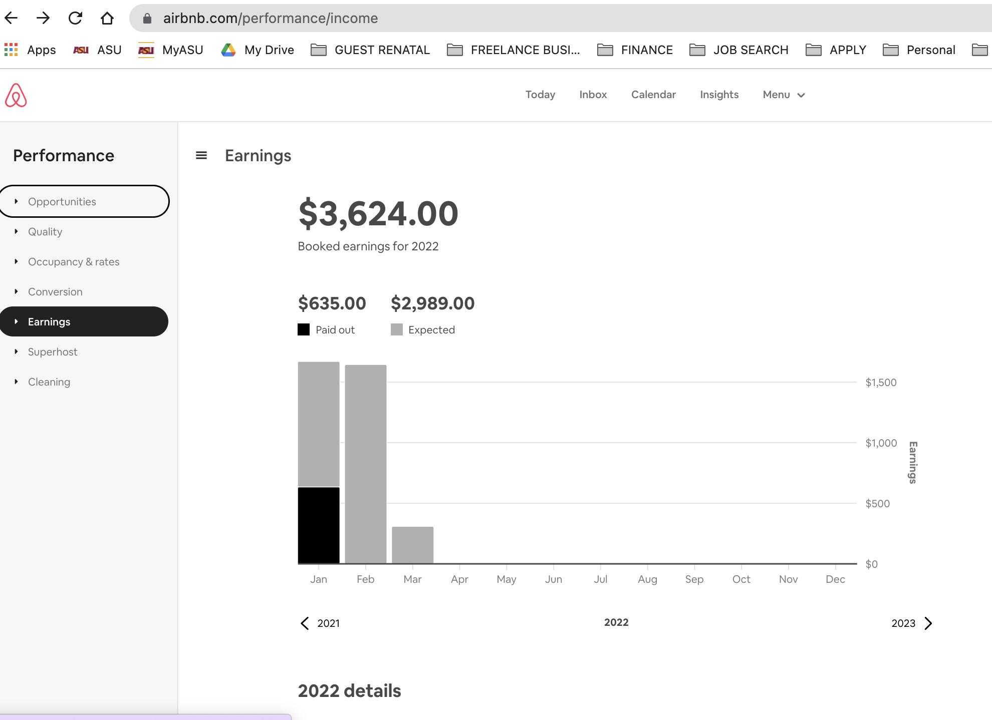
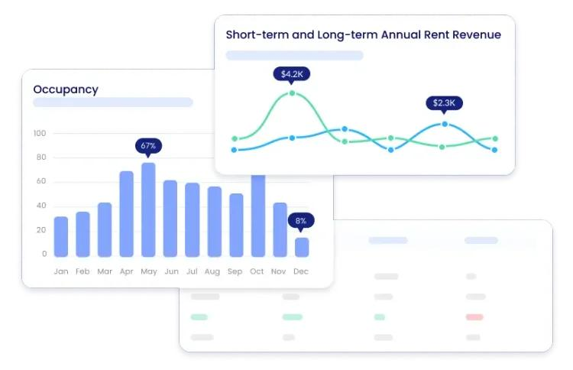
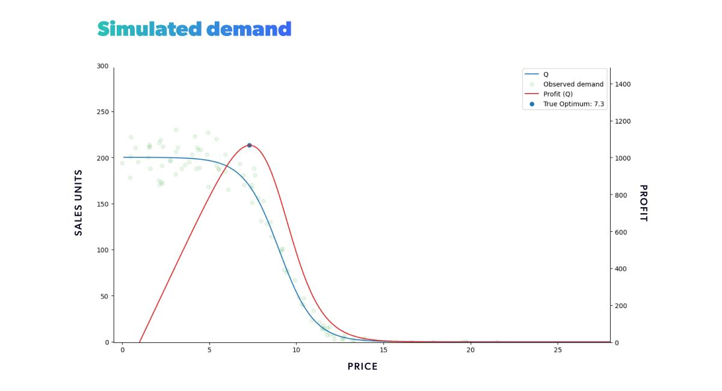
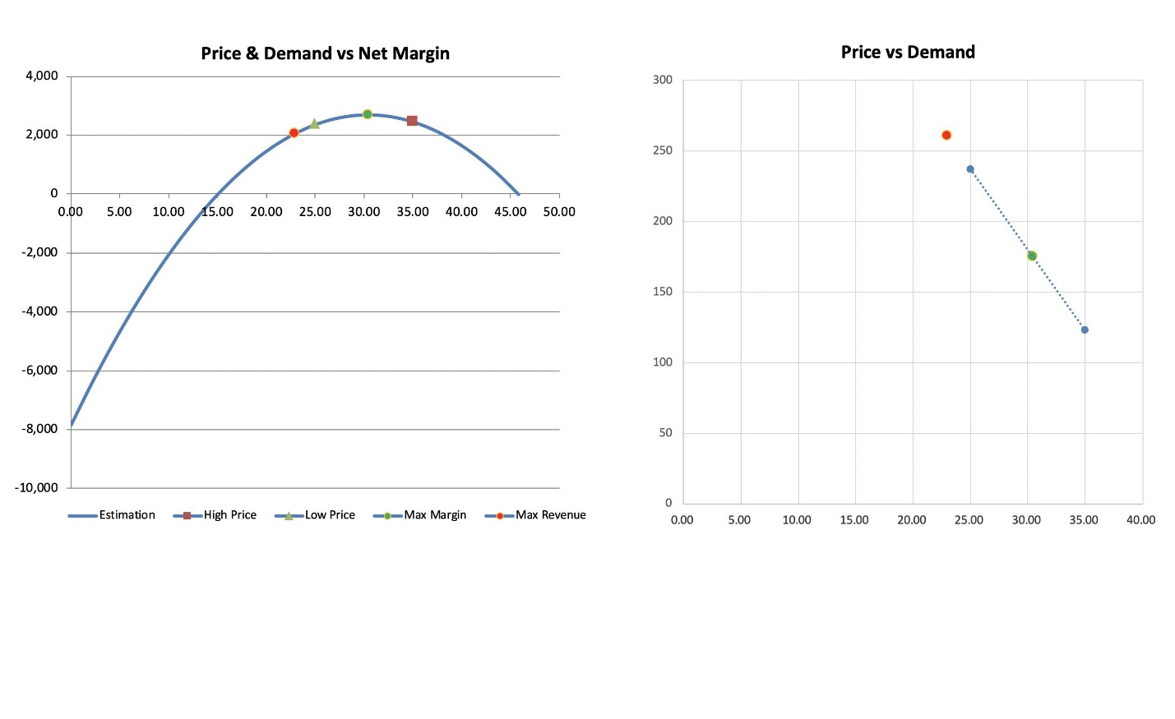
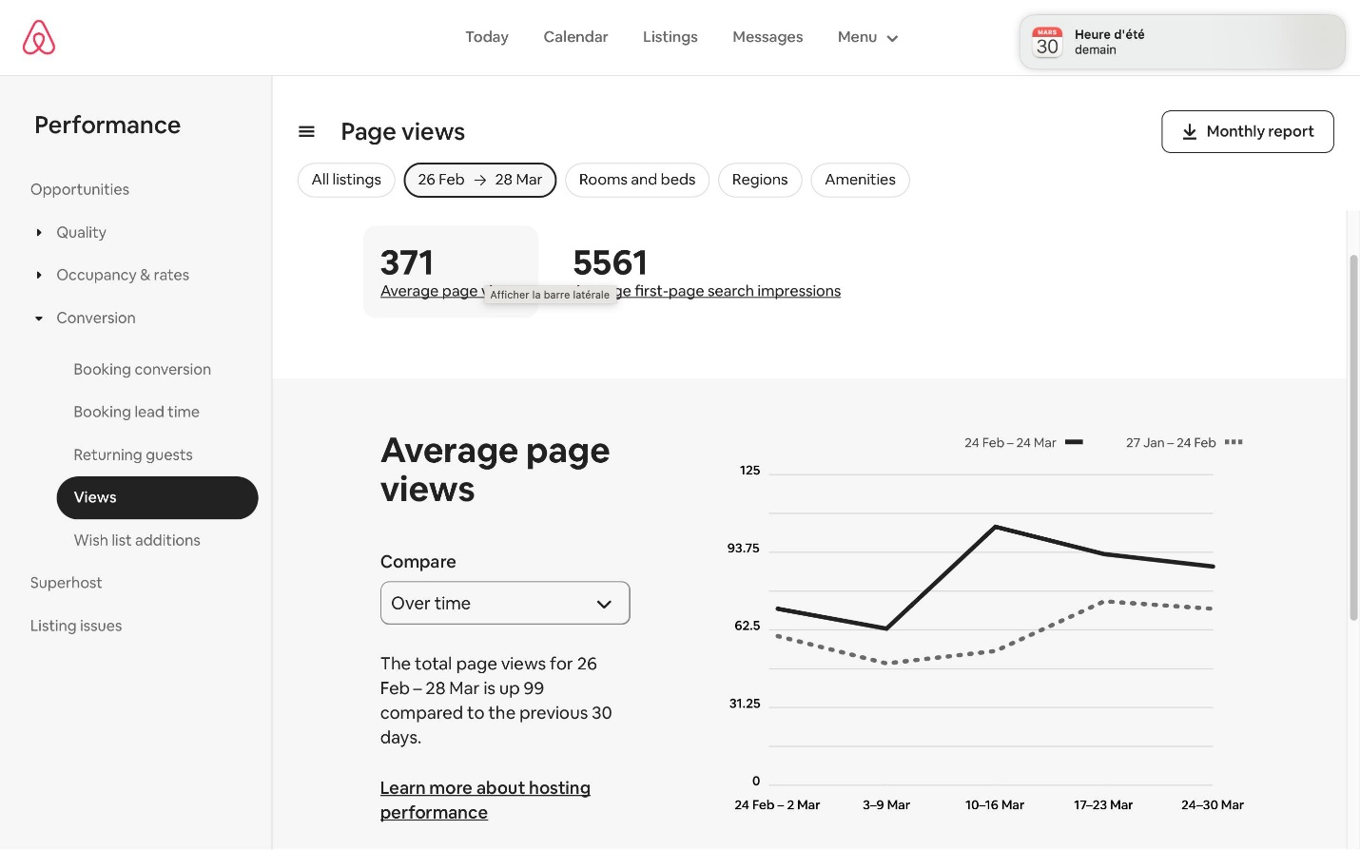

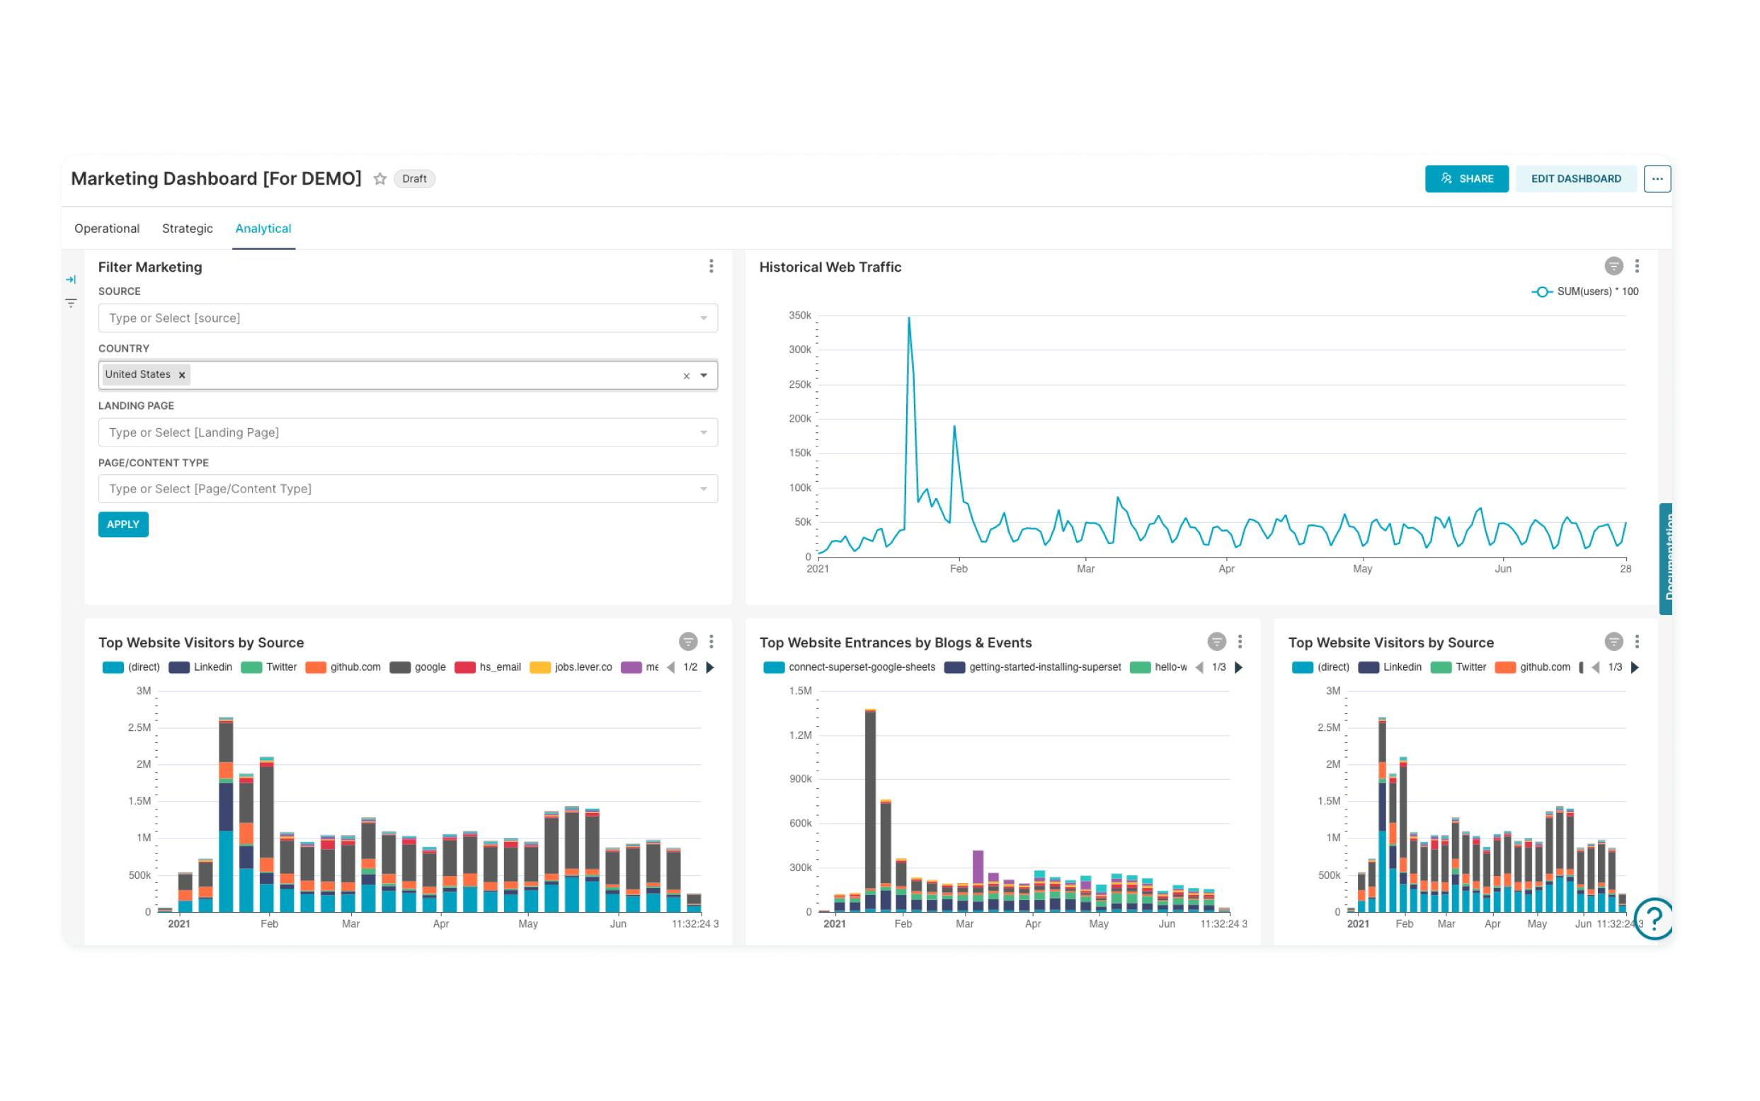
What you show on ONE graph:
X-axis: Time (hours / days)
Y-axis: Multiple overlays
Lines:
- 🔵 Demand Curve
- 🟢 Expected Bookings
- 🟡 Price Line
- 🟣 Revenue Projection
- 🔴 Risk Zones (shaded areas)

📈 B. Price vs Revenue Curve (Optimization View)
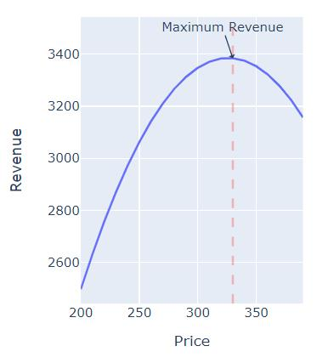
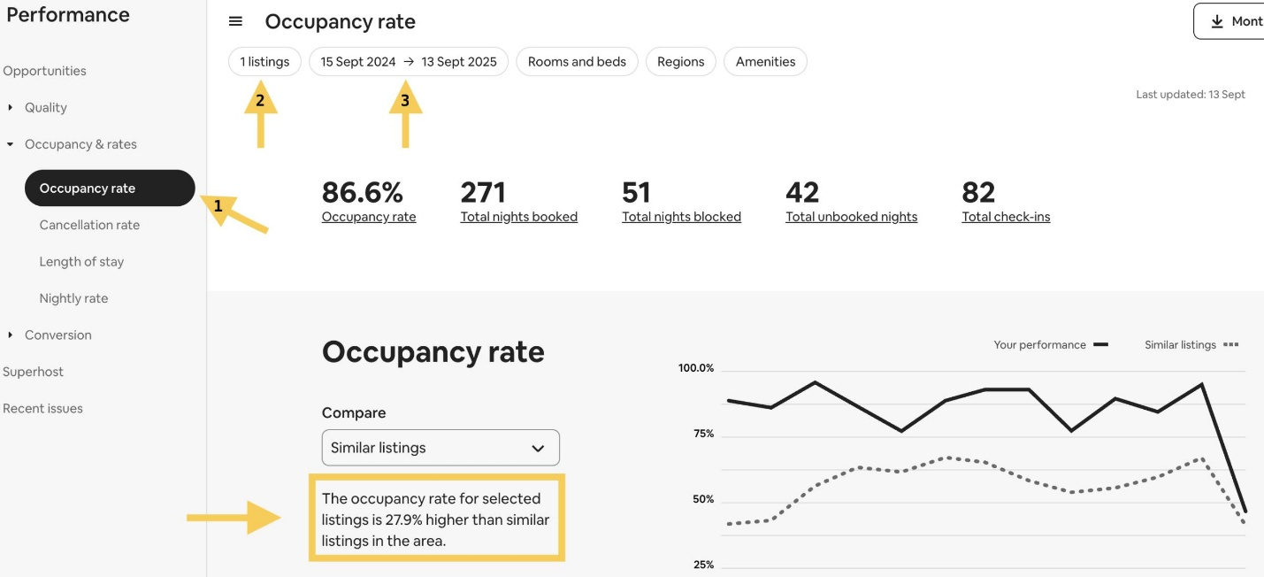
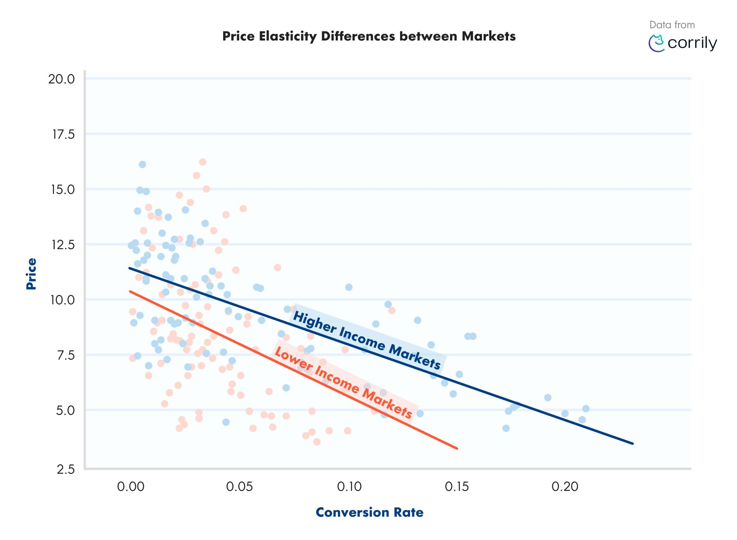
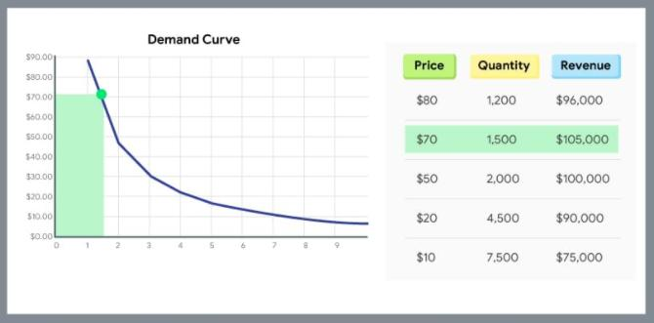
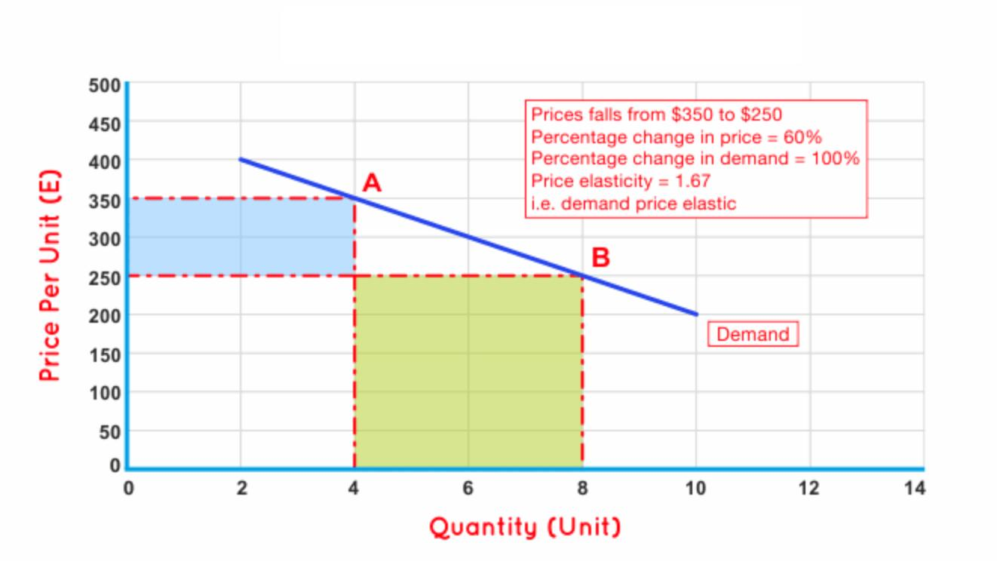
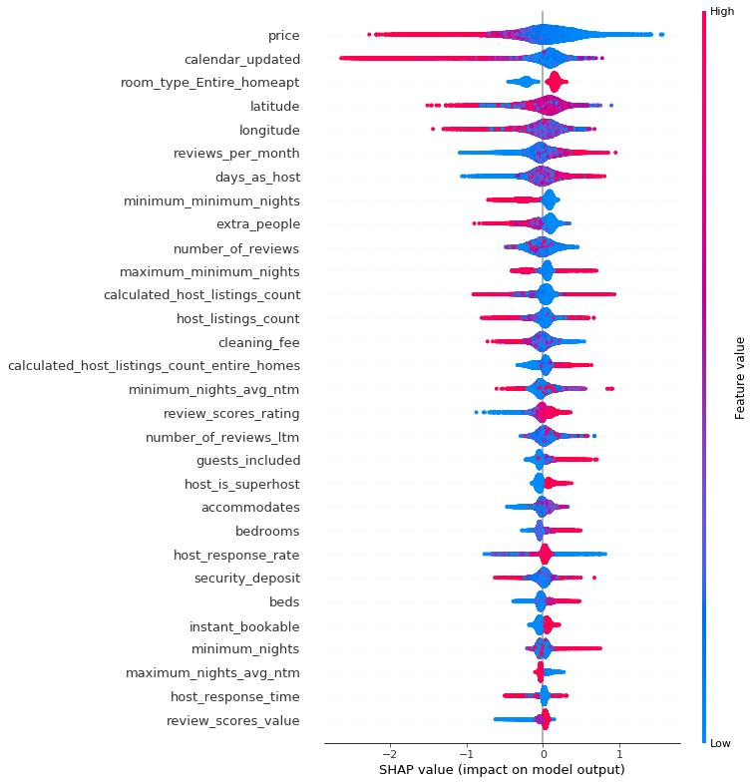
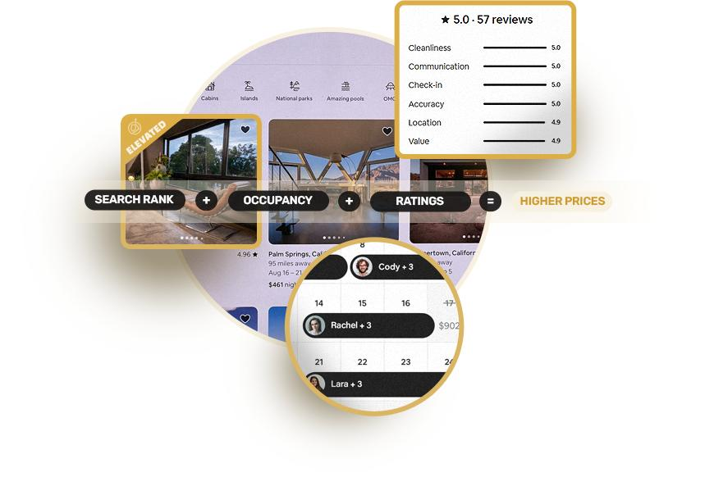
This is where your pricing model shines.
- X-axis: Price
- Y-axis: Revenue
👉 Highlight:
- Optimal price (peak)
- Current price
- Suggested price

⚠️ C. Risk + Availability Layer
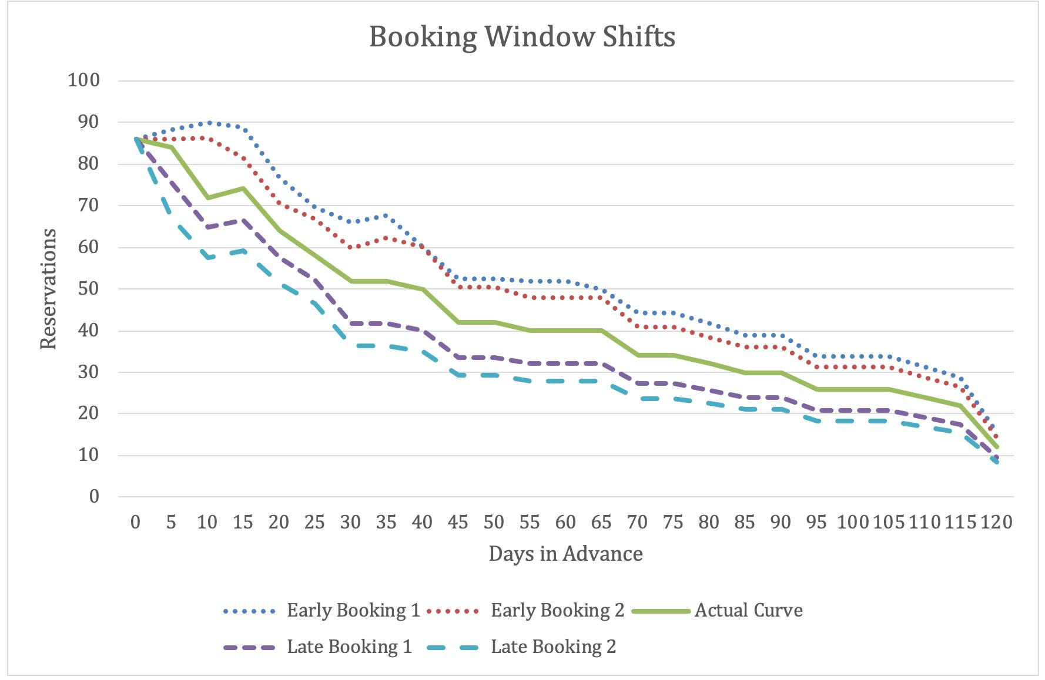
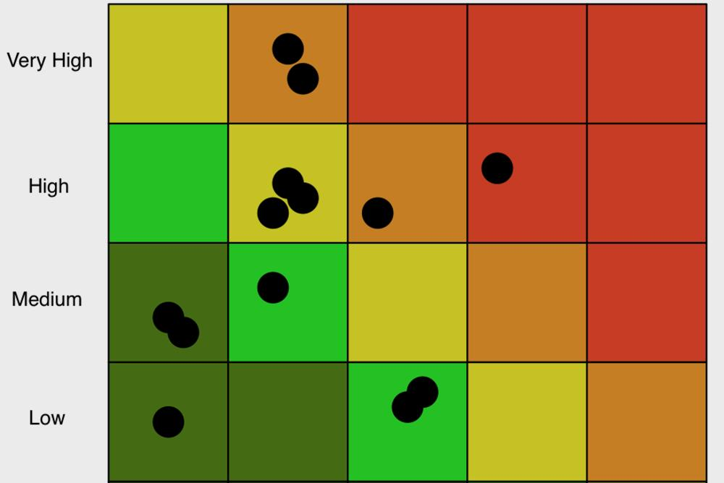
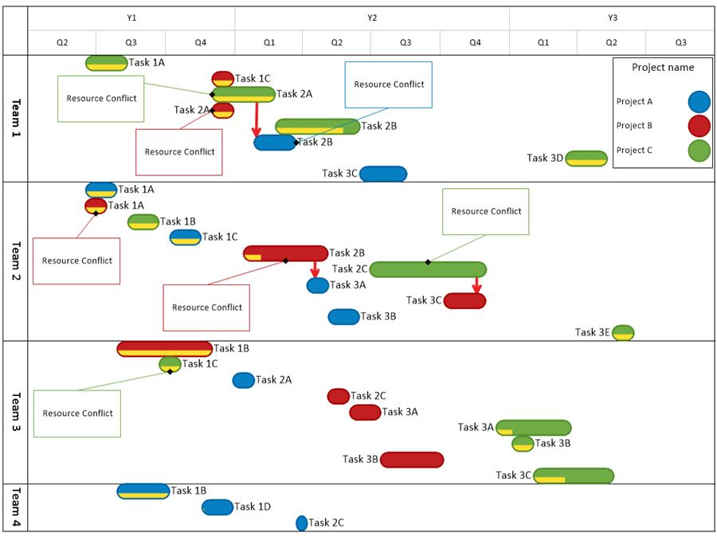
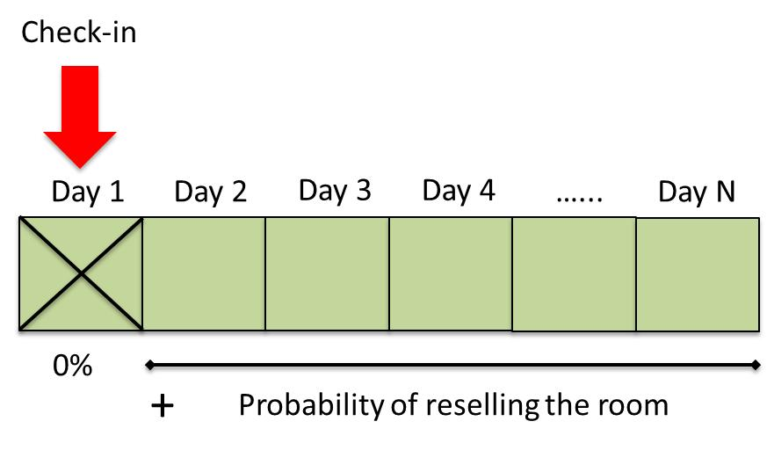
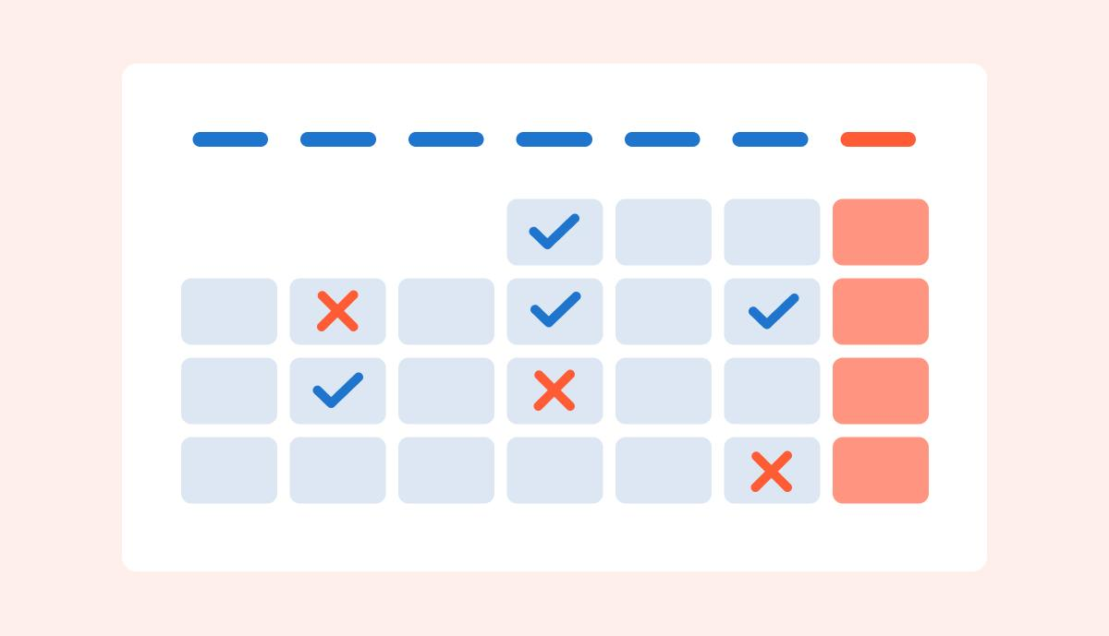
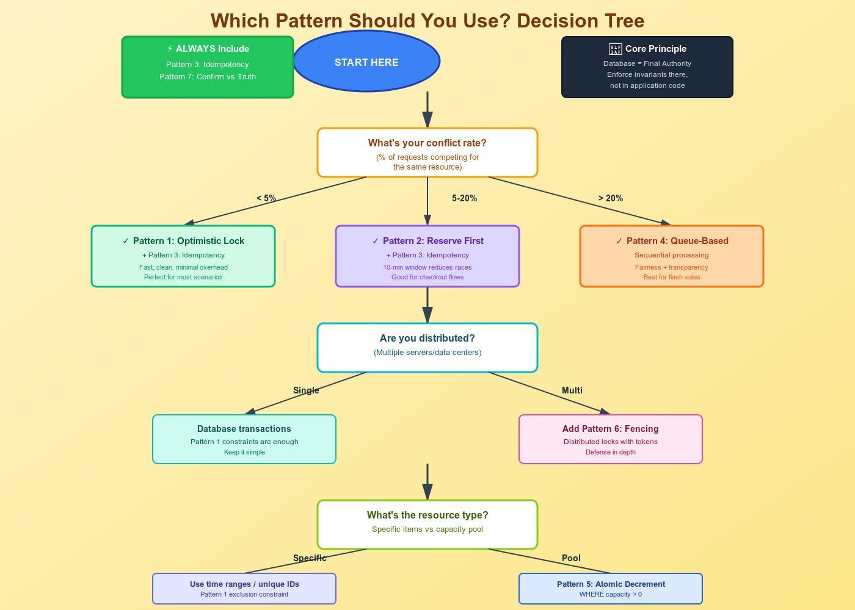
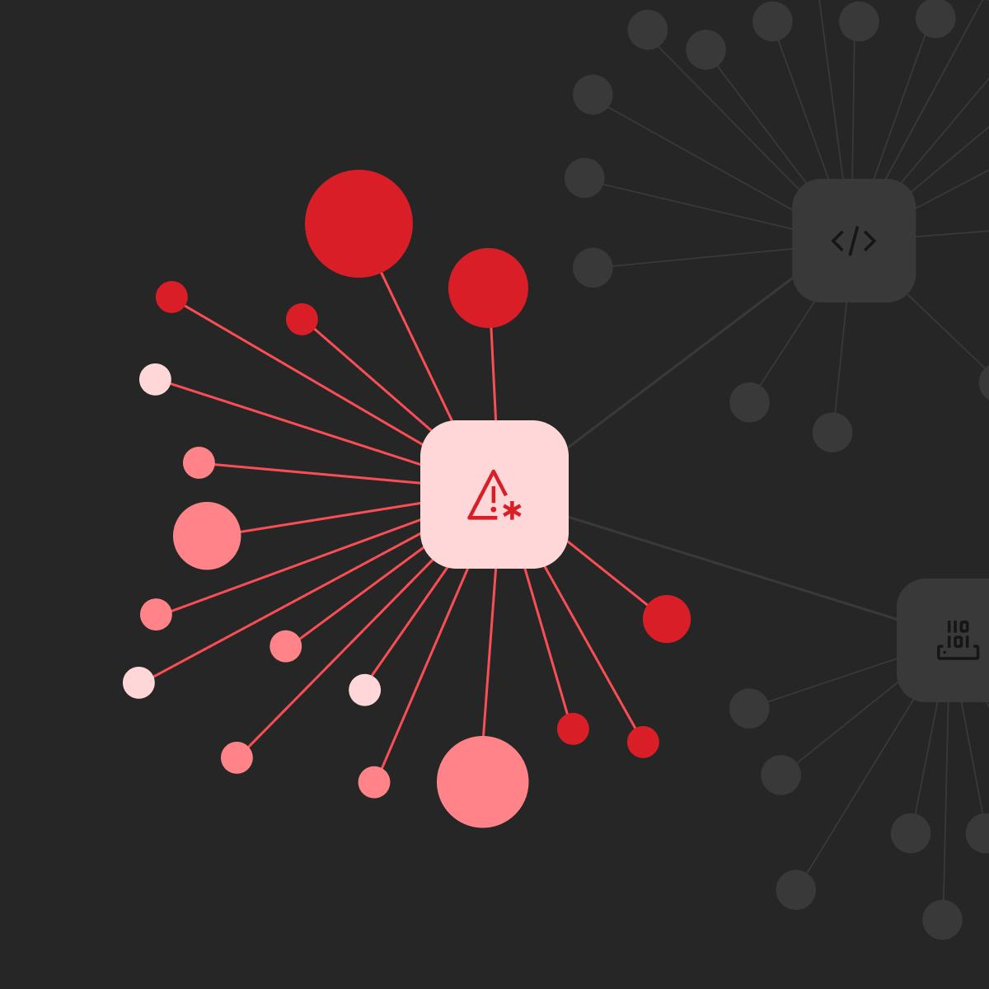
Overlay on timeline:
- Red zones → high risk (locks)
- Yellow → unstable
- Green → safe booking window

⚙️ 3. Backend Simulation Engine (How it works)
This is the missing piece in your system.

🔁 Simulation Flow
def run_simulation(listing_id, time_range, price_scenarios):

results = []

for t in time_range:

demand = demand_model.predict(t)

risk = risk_model.predict(t)

availability = availability_model.predict(t)

for price in price_scenarios:

conversion = conversion_model.predict(price, demand)

bookings = demand * conversion * availability

revenue = bookings * price

adjusted_revenue = apply_commission(revenue)

decision = orchestrator(
demand, risk, availability, revenue
)

results.append({
"time": t,
"price": price,
"demand": demand,
"risk": risk,
"availability": availability,
"conversion": conversion,
"bookings": bookings,
"revenue": adjusted_revenue,
"decision": decision
})

return results

🔗 4. How YOUR Models Plug In (Direct Mapping)
From your actual system:

Demand
- demand_forecast()
→ feeds simulation baseline

Risk
- risk_score()
→ blocks bookings or reduces conversion

Availability
- availability_probability()
→ multiplies bookings

Pricing Engine
- Expected revenue optimization
→ drives price vs revenue curve

Commission Engine
- Markup rules + guardrails
→ modifies final revenue

Orchestrator
- Final decision logic
→ chooses best outcome

📊 5. Output Data Structure (Frontend Ready)
This is what your API should return:
{
"timeline": [
{
"time": "2026-05-02T10:00:00",
"demand": 0.82,
"risk": 0.3,
"availability": 0.95,
"price": 120,
"conversion": 0.21,
"bookings": 17,
"revenue": 2040,
"decision": "PROMOTE"
}
],
"price_curve": [
{ "price": 80, "revenue": 1500 },
{ "price": 100, "revenue": 2100 },
{ "price": 120, "revenue": 2040 }
],
"recommendation": {
"best_price": 100,
"expected_revenue": 2100
}
}

🎯 6. Key Features That Make This Powerful
✅ Scenario Simulation
- “What if I raise price by 20%?”
✅ Real-Time Feedback
- Uses live demand + risk
✅ AI + Deterministic Together
- Matches your architecture perfectly
✅ Host Decision Clarity
- No guessing

🚀 7. What You’re Missing (Honest CTO Note)
Based on your system:
You have:
- Models ✔️
- APIs ✔️
- Decision engine ✔️
But you don’t yet have:
❌ A unified simulation runner
❌ A visual layer tying models together
❌ Scenario testing (what-if engine)

🧠 8. If You Build This, You Get:
- Airbnb-level host intelligence
- A major product differentiator
- Investor-ready feature
- Monetization leverage (premium analytics)

👉 Next Step (Pick One)
I can take this further into:
- Full Figma UI wireframe (pixel-level layout)
- Production-ready Node.js / Python simulation service
- Database schema + API design
- Real-time streaming version (Kafka-based)
Just tell me what you want next.

Alright, let’s lock this in properly. I’ll design this like something your engineers can actually build without guessing.

🧩 1. Full System You’re Building
You’re creating a new service:
👉 Simulation Intelligence Service (SIS)
It sits between:
- your AI models
- your orchestrator
- your frontend dashboard

🏗️ 2. Architecture (How it plugs into your system)
Frontend (Host Dashboard)
↓
Simulation API (NEW)
↓
-----------------------------------
| Demand Model |
| Risk Model |
| Availability Model |
| Pricing Engine |
| Commission Engine |
| Orchestrator |
-----------------------------------
↓
Simulation Output (time series + scenarios)
This uses what you already built (no rewrite needed).

⚙️ 3. Backend Implementation (Production-Ready Structure)
📁 Service Structure (Node + Python hybrid)
simulation-service/
├── api/
│ └── simulation.controller.ts
├── engine/
│ ├── simulation.engine.ts
│ ├── scenario.runner.ts
│ ├── pricing.adapter.ts
│ ├── risk.adapter.ts
│ ├── demand.adapter.ts
│ ├── availability.adapter.ts
│ └── orchestrator.adapter.ts
├── cache/
│ └── redis.cache.ts
├── models/
│ └── simulation.types.ts
└── workers/
└── simulation.worker.ts

🧠 4. Core Engine (This is the heart)
🔁 Simulation Engine
export async function runSimulation(input: SimulationInput) {
const results = [];

for (const t of input.timeRange) {

const demand = await demandModel.predict(t);
const risk = await riskModel.predict(t);
const availability = await availabilityModel.predict(t);

for (const price of input.priceScenarios) {

const conversion = await pricingModel.predictConversion(price, demand);

const bookings = demand * conversion * availability;

const revenue = bookings * price;

const finalRevenue = applyCommission(revenue);

const decision = orchestrator.decide({
demand,
risk,
availability,
revenue: finalRevenue
});

results.push({
time: t,
price,
demand,
risk,
availability,
conversion,
bookings,
revenue: finalRevenue,
decision
});
}
}

return results;
}

🔌 5. Adapters (Hook into YOUR existing models)
This is key: don’t rewrite models—wrap them.

Demand Adapter
export async function getDemand(t) {
return await aiService.post("/demand-forecast", { hour_of_day: t.hour });
}

Risk Adapter
export async function getRisk(data) {
return await aiService.post("/risk-score", data);
}

Availability Adapter
export async function getAvailability(data) {
return await aiService.post("/availability-probability", data);
}

Pricing Adapter
Uses your pricing engine logic:
- expected revenue
- conversion probability
(Already implemented in your pricing system)

Commission Adapter
Applies:
- markup rules
- guardrails
From your Smart Commission Engine

Orchestrator Adapter
Calls your ranking/decision system:
- EV optimization
- fairness rules

📊 6. API Design (Frontend will call this)
🚀 POST /v1/simulation/run
Request:
{
"listing_id": "abc123",
"time_range": ["2026-05-02T00:00:00", "2026-05-03T00:00:00"],
"price_scenarios": [80, 100, 120, 150]
}

Response:
{
"timeline": [...],
"price_curve": [...],
"best_scenario": {
"price": 100,
"revenue": 2100
},
"risk_summary": {
"high_risk_periods": ["14:00-16:00"]
}
}

⚡ 7. Performance Strategy (VERY IMPORTANT)
If you don’t do this, it will be slow.

✅ Cache Results (Redis)
- Key:
simulation:{listing_id}:{date}:{price_hash}
- TTL: 5–15 minutes

✅ Precompute (Background Jobs)
Run simulations:
- every hour
- when demand spikes
- when price changes

✅ Parallel Execution
Run models concurrently:
const [demand, risk, availability] = await Promise.all([
getDemand(t),
getRisk(data),
getAvailability(data)
]);

🎨 8. Frontend (React Dashboard Layout)

🧱 Layout
--------------------------------------------------
| Header (Listing + Filters) |
--------------------------------------------------
| Main Graph (Demand + Revenue + Price) |
--------------------------------------------------
| Price Optimization Curve |
--------------------------------------------------
| Risk Timeline |
--------------------------------------------------
| AI Recommendation Card |
--------------------------------------------------

📊 Charts (Recharts / D3)

1. Multi-Line Chart
- demand
- bookings
- revenue
- price

2. Price Optimization Curve
- highlight peak revenue

3. Risk Heatmap
- red zones = blocked

🧠 9. Advanced Features (This is where you win)

🔥 Scenario Slider
User drags:
- price ↑
- demand changes
- revenue updates live

🔮 What-If Simulation
- “What if demand spikes 30%?”
- “What if risk increases?”

🧬 AI Recommendation
{
"action": "INCREASE_PRICE",
"reason": "High demand, low risk",
"confidence": 0.87
}

🚨 10. CTO-Level Reality Check
Right now you are here:
- Models exist ✔️
- Logic exists ✔️
- Architecture exists ✔️
But missing:
❌ Unified simulation service
❌ Real-time scenario engine
❌ Visualization layer

🏁 11. Build Order (Do THIS in sequence)
Phase 1 (Fast Win – 1 week)
- Simulation API
- Basic graph
Phase 2 (Power – 2–3 weeks)
- Price optimization curve
- Risk overlay
Phase 3 (Elite – 3–5 weeks)
- Scenario engine
- Real-time updates
- AI recommendations

💬 Final Thought
What you’re building here is not just a feature.
👉 It’s your competitive moat
Airbnb shows data.
You show decisions before they happen.

👉 Next Move
Say one of these and I’ll go deeper:
- “Build the frontend UI (React code)”
- “Build the simulation microservice (full repo code)”
- “Turn this into Jira tickets for my team”

